Colin James AV REQUIREMENTS
ROOM SETUP GUIDELINES FOR COLIN JAMES
If you have any questions please feel free to contact us via phone or email.
p: 1300 556 933
e: support@colinjamesmethod.com

ROOM SETUP GUIDELINES
• Room Size: Approx 110m2 (For training only) Please note this size room is required to allow for breakout sessions/facilitation

• 2 x Identical flipchart stands with good quality flip chart paper (Colin will bring his own pens)

• 2 x Chairs/Stools - set either side of the flipcharts (1 x either side)

• 2 x Presenter Tables with water jug and glass - set either side of the flipcharts (1 x either side)

• Cabaret style seating (set open ended) – ideally set wide across room rather than deep If round tables not available please note rectangle tables are OK and set herringbone style (See next page for more information on seating styles)

• Logistics table at the back of the room set for 2 x people with 2 x chairs & water jug and glasses (Training only)

• Flowers on 2 x tables either side of flipcharts (Desirable but not essential)

• Lapel microphone if group numbers above 24

• Camera on flip charts and projected onto screen for groups larger than 50 cabaret style or larger than 100 theatre style

• No clocks in room

• No mints in room

• No poles in room obstructing view

• Data projector and screen to right of room (only if required)

• Catering to be served outside of room

CABARET STYLE SEATING  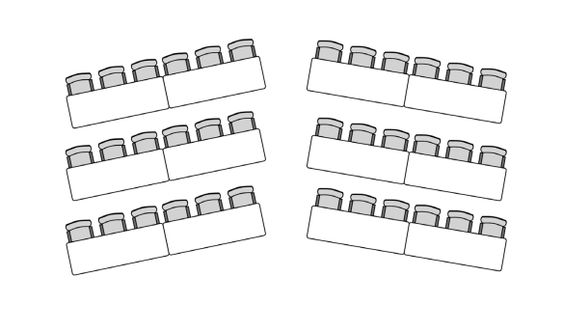  Audience seated around the circumference facing inwards, however there is an open end, with the audience seated in an arc facing forwards. | HERRINGBONE STYLE SEATING  Each consecutive row of chairs and tables are angled inwards.
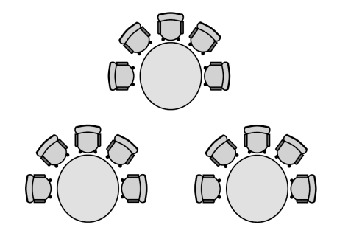

IDEAL TRAINING ROOM LAYOUT
